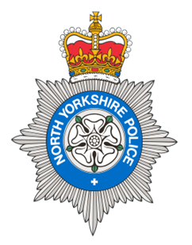
PCSO 5725 Jamie-Leigh Coburn
Produced: 14th February 2026
Date of meeting- 17 February 2026

BROUGH WITH ST GILES
PARISH COUNCIL MEETING 17th February 2026
POLICE REPORT

17/01/2026 – 14/02/2026

Please note that under the police crime reporting system, all reports of criminal activity are recorded as crimes. However, if at a later date it is ascertained that no crime has been committed, this will not show on parish council report due to time delay.

Crimes = 0
Reported crime for the same period last year = 5

Anti-Social Behaviour = 0
Reports of ASB for the same period last year = 0

OTHER REPORTS includes Highway Disruption and RTC’s
Other reports for the same period last year= 2

Personal/Safety/Warning Incidents = 3
Other reports for the same period last year = 5

Community Messaging
North Yorkshire Community Messaging allows members of the public to register to receive alerts, crime notifications and community news from organisations. It is a way of maintaining contact with Neighbourhood Watch and Rural Watch groups. Neighbourhood & Rural Watch have their own database within community messaging for their members.

You can sign up to receive alerts as a member of the public here:
https://www.northyorkshirecommunitymessaging.co.uk/

If you wish to speak to your local Neighbourhood PCSO you can send an e-mail to PCSO5725 Jamie-leigh.Coburn@northyorkshire.police.uk , phone 101, choose option 2, and follow the prompts.

On 21st February 2026 at 11:00 – 12:00 PCSO Katie WHITEHEAD will be holding an engagement event at COLBURN library. Everyone is welcome.

